S-Rank
An Intelligent Reasoning System for Fair and Traceable Skills-Based Candidate Ranking

Group Number: [04]

Group Members:

1. Muthaiah Muneeswaran (A0019650J)
2. [Member Name 2] ([Insert Student ID])
3. [Member Name 3] ([Insert Student ID])
4. [Member Name 4] ([Insert Student ID])

Date of Submission: March 29, 2026

1. Introduction

1.1 Project Overview
S-Rank is a sophisticated Intelligent Reasoning System (IRS) developed to transition recruitment from traditional, keyword-reliant screening to a deep, logic-based evaluation of human capital. While standard Applicant Tracking Systems (ATS) often fail to recognize talent due to rigid string-matching, S-Rank utilizes Symbolic Reasoning and Knowledge Graphs to interpret the semantic meaning behind a candidate’s experience. By mapping unstructured resume data against standardized industry frameworks, the system identifies the underlying competencies that make a candidate a "best-fit" for a role, regardless of the specific terminology used in their profile.

1.2 Regulatory Context: The Workplace Fairness Act (WFA) 2026
The development of S-Rank is strategically timed with the full implementation of Singapore’s Workplace Fairness Act (WFA). Under this legislation, AI-driven hiring is no longer permitted to be a "black box." Employers are now legally mandated to ensure that all automated screening is transparent, merit-based, and traceable. S-Rank solves this regulatory hurdle by providing an automated Reasoning Trace for every decision, ensuring full legal and ethical compliance through a documented audit trail.

1.3 National Strategic Alignment: AI-Bilingualism
In alignment with Singapore’s National AI Strategy 2.0, this project focuses on identifying "AI-Bilingual" talent. These are professionals who possess deep domain expertise (e.g., in Finance, Law, or HR) while simultaneously demonstrating the technical fluency to orchestrate AI tools within that domain. S-Rank is specifically programmed to reason through a candidate's history to find this combination of skills, which is essential for Singapore’s 2026 digital economy.

1.4 Project Goals
- Knowledge Codification: To transform the SkillsFuture Singapore (SSG) framework into a machine-readable Fact Base for precise skill-to-role mapping.
- Explainable AI (XAI): To implement an Inference Engine that doesn't just provide a "score," but explains its logic, acting as a cognitive assistant to human recruiters.
- Operational Efficiency: To utilize Informed Search to bridge the gap between candidate ranking and final interview scheduling, optimizing the entire business resource chain.

2. Project Background / Market Context

2.1 The 2026 Singapore Talent Scarcity Paradox
As of 2026, Singapore’s labor market is characterized by a "scarcity paradox." While broad talent shortages have stabilized, the demand for specialized AI Literacy has intensified. Organizations are no longer engaged in mass hiring; instead, they are focused on selective, skills-based recruitment to support structural digital transformation. Conventional screening methods are failing to keep pace with this shift, as they cannot identify "AI-Bilingual" professionals who possess both niche domain expertise and technical AI fluency.

2.2 The Operational Screening Bottleneck
Recruitment teams are currently facing unprecedented operational pressure:
- Application Surges: Job applications per posting have increased, yet recruiters report significant difficulty in finding truly qualified candidates through keyword filters.
- Trust and Transparency: While most Singaporean firms use AI in their workforce strategies, a critical trust gap exists regarding algorithmic opacity.
- Audit Readiness: With the WFA now in force, recruiters require tools that provide Explainable AI (XAI). There is a critical market gap for a system that justifies its rankings with a logic-based audit trail, protecting firms from legal liability and unconscious bias.

3. Project Scope

3.1 Technical Methodology
S-Rank is engineered as a multi-stage Intelligent Reasoning System that integrates four distinct technical domains to solve the complexity of modern, fair, and efficient recruitment:
- Knowledge Discovery & Recommender Systems: The initial stage involves Knowledge Discovery from unstructured data. By applying NLP to a Fact Base of resumes and JDs, the system identifies latent patterns. This module functions as a Content-Based Recommender System, generating a preliminary candidate ranking based on semantic relevance.
- Decision Automation (Forward Chaining): The Inference Engine applies Forward Chaining logic to deduce new information. If a candidate possesses "Python" and "Financial Analysis," the engine fires a rule to assert the fact: is_AI_Bilingual. It also enforces Hard Constraints related to the WFA.
- Cognitive Systems (Knowledge Graphs & XAI): S-Rank incorporates a Skills Ontology (built on the SSG framework) to reason about skill relationships. Crucially, it generates a Reasoning Trace—a human-understandable explanation of the logical path taken—providing the Explainable AI (XAI) required for audits.
- Business Resource Optimization (Informed Search): The final stage utilizes A Search* algorithms to automate interview scheduling. This algorithm evaluates constraints—recruiter expertise, availability, and candidate priority—to find the optimal sequence that minimizes "Time-to-Hire."

3.2 MVP Boundaries and Constraints
- Domain Focus: The MVP is calibrated for the IT and Financial Services sectors.
- Legal Constraints: The system treats WFA and PDPA as "Hard Constraints." Any reasoning path using protected characteristics is programmatically blocked.
- Data Privacy: All input data is de-identified before the reasoning process begins.

4. Data Collection and Preparation
- Knowledge Sources: Data is acquired from MyCareersFuture job descriptions and the SkillsFuture Singapore (SSG) framework.
- Fact Extraction: Unstructured resumes are processed into a structured Fact Base (e.g., has_skill(Candidate_X, Python)).
- Validation: Strict schema enforcement (Pydantic) ensures the integrity of the "Fact Base" before reasoning begins.

5. System Design

5.1 High-Level Architecture
The system follows a four-stage lifecycle: Extraction, Deduction, Validation, and Optimization.
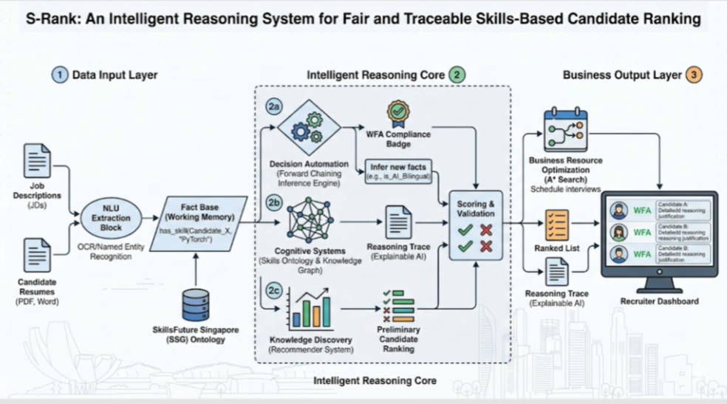

5.2 Technical Highlight: Inference Logic
The engine uses IF-THEN logical statements to perform deductions:
- Skill Deduction: IF candidate_has(Python) AND candidate_has(Finance) THEN infer(AI_Bilingual_FinTech).
- Merit Constraint: IF job_requires(CPA) AND NOT(candidate_has(CPA)) THEN status(Ineligible).

5.3 User Interface (UI) and Interaction Design
The S-Rank interface is designed as a Cognitive Dashboard:
- Extraction Visualization: Side-by-side comparison of raw text vs. the Structured Fact Base for human-in-the-loop verification.
- Logic Transparency (XAI): A "Why This Rank?" button displays the Reasoning Trace and WFA Compliance Badge.
- Optimized Scheduling: A proposed Interview Roadmap generated by the A* Search algorithm, allowing recruiters to see how constraints were balanced.

6. Challenges and Roadblocks
The development of the S-Rank MVP involves navigating several complex technical and domain-specific hurdles. Identifying these roadblocks early allows for a more robust system design and risk mitigation strategy.
6.1 The Knowledge Acquisition Bottleneck
One of the primary challenges is the Knowledge Engineering process. Transforming the SkillsFuture Singapore (SSG) framework and industry-specific hiring criteria into a formal, machine-readable Ontology is labor-intensive.
- The Problem: Human-written job descriptions are often ambiguous or use non-standard terminology.
- The Impact: If the system cannot accurately map a candidate’s "unique" skill phrasing to the standardized Knowledge Graph, the Inference Engine will fail to fire the correct rules, leading to an inaccurate ranking.
- Mitigation: S-Rank utilizes a NLU Extraction Block with a "fuzzy matching" layer to bridge the gap between natural language and formal symbolic logic.
6.2 Cold-Start and Data Sparsity
Reasoning systems, particularly those using Forward Chaining, require a baseline of facts to begin making deductions.
- The Problem: New or "cold-start" roles (e.g., emerging roles in Quantum Computing or Green Fintech) may not yet have established rules within our Knowledge Base.
- The Impact: The system may struggle to rank candidates for these roles because the Inference Engine has no historical logic to follow.
- Mitigation: We are implementing a "Generalist Meritocracy" rule-set that defaults to high-level transferable skills when specific domain rules are unavailable, ensuring no candidate is unfairly penalized by a lack of niche data.
6.3 Computational Complexity in Resource Optimization
The final stage of S-Rank involves Business Resource Optimization using the A Search* algorithm.
- The Problem: As the number of candidates and recruiters grows, the "state space" for interview scheduling expands exponentially.
- The Impact: Finding a mathematically "optimal" schedule can become computationally expensive, potentially leading to slow system response times (latency) for the recruiter.
- Mitigation: We utilize Heuristic-Driven Search, where the A* algorithm is guided by specific "priority weights" (e.g., prioritizing senior-level interviews), allowing the system to find a "near-optimal" solution quickly without exhausting computational resources.
6.4 Maintaining Bias-Free Logic (WFA Compliance)
Ensuring the Inference Engine is truly objective is a continuous challenge.
- The Problem: Even symbolic rules can inadvertently mirror human bias if the Knowledge Engineering phase is influenced by historical hiring patterns.
- The Impact: A rule that favors "10 years of experience" might inadvertently discriminate against younger, highly-skilled "AI-Native" talent.
- Mitigation: S-Rank includes a Constraint Validation layer that specifically audits every rule against the Workplace Fairness Act (WFA) guidelines before it is deployed into the live environment.

7. Future Work
The S-Rank MVP establishes a foundation for logic-based recruitment. Future iterations will focus on scaling the system’s reasoning capabilities and expanding its industrial applicability through the following three phases:
7.1 Expansion of the Domain Knowledge Graph
While the current version is optimized for IT and Financial Services, the underlying Skills Ontology is designed for modular expansion. Future work will involve:
- Cross-Industry Mapping: Integrating specialized ontologies for Healthcare and Green Energy, mapping clinical competencies and sustainability certifications to support the Singapore Green Plan 2030.
- Multilingual NLU: Enhancing the Extraction Block to process resumes in regional languages (e.g., Mandarin, Bahasa Melayu, and Tamil). This ensures the Reasoning Trace remains accurate for a diverse, international talent pool while maintaining strict compliance with the Workplace Fairness Act.
7.2 Implementation of Case-Based Reasoning (CBR)
To improve the system’s handling of "non-traditional" candidates, we plan to integrate a Case-Based Reasoning (CBR) module. This will allow S-Rank to:
- Learn from Historical Success: Store "anonymized cases" of employees who were successful high-performers despite having non-linear career paths.
- Heuristic Adaptation: When the system encounters a mid-career switcher, it can "retrieve" similar successful transitions from the past to justify a high ranking, effectively identifying high-potential talent that a purely rule-based system might overlook.
7.3 Collaborative Cognitive Loop
The next phase of UI development will focus on a Human-in-the-Loop (HITL) feedback mechanism. This transforms S-Rank from a tool into a Cognitive Assistant:
- Dynamic Rule Adjustment: Recruiters will be able to "nudge" the system by adjusting the weight of specific logical rules (e.g., increasing the priority of "Leadership Experience" for a specific role).
- Real-Time Re-Reasoning: The system will immediately re-run the A Search* optimization and Inference Engine to show the recruiter the impact of their feedback on the final shortlist and interview schedule.
7.4 Advanced Predictive Resource Optimization
Beyond scheduling, future work will apply Informed Search to broader business resources, such as:
- Predictive Time-to-Fill: Using historical search data to predict exactly when a role will be filled based on current candidate flow.
- Cost-Benefit Reasoning: Providing a logical justification for the "Cost-per-Hire" based on the complexity of the skills deduced during the reasoning phase.

8. Appendix

8.1 Declaration of References & AI Usage
- Reference Declaration: We hereby declare that the background research, market context, and regulatory framework analysis in this proposal are grounded in the 2026 Singaporean Economic Reports, the Workplace Fairness Act documentation, and National AI Strategy 2.0.
- Generative AI Disclosure: In accordance with academic guidelines, we disclose that Google Gemini was utilized as a collaborative advisor to structure this document and brainstorm Singapore-specific use cases. All outputs were reviewed and validated by the group members for technical accuracy.

8.2 Acknowledgements
The group expresses gratitude to the SkillsFuture Singapore (SSG) board for the frameworks and guidance that form the foundation of this reasoning system.

